SIMATS Engineering — Library Book Reservation System (SaaS)
Name:JAGADEESH A
Reg no:192521294
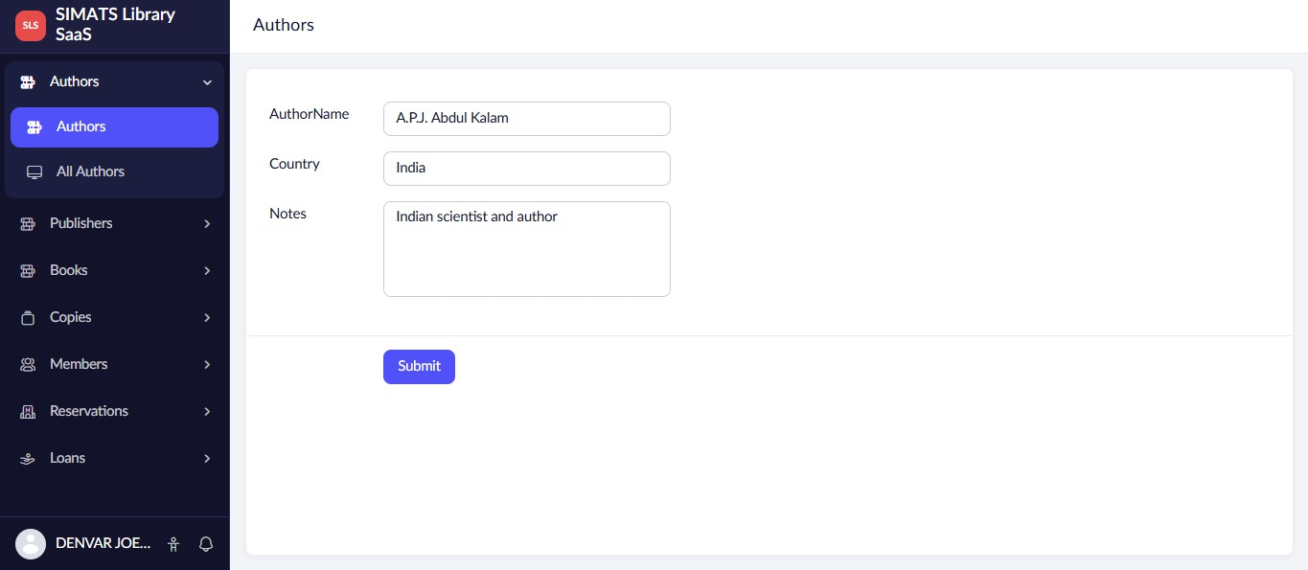
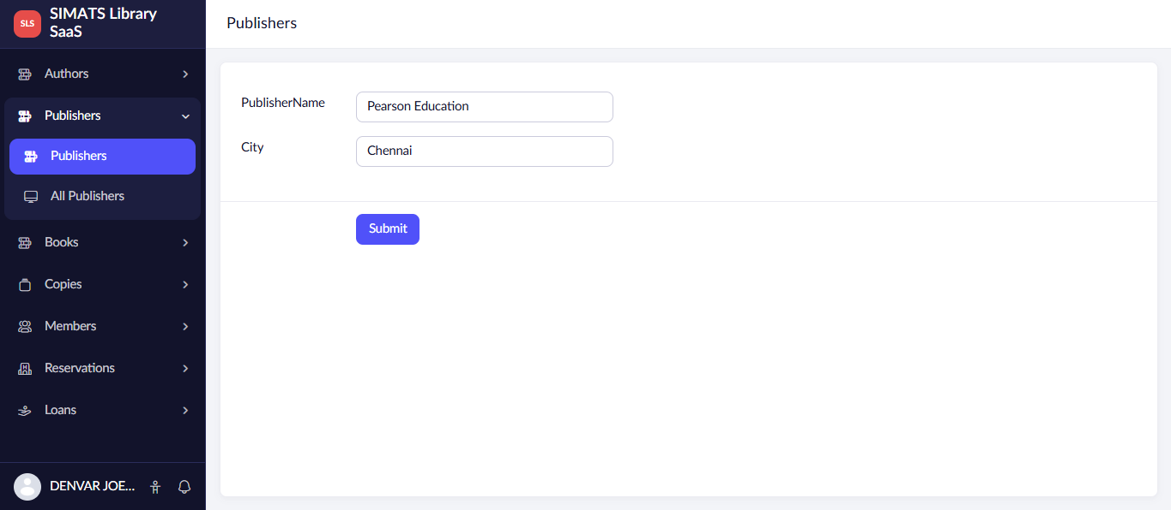

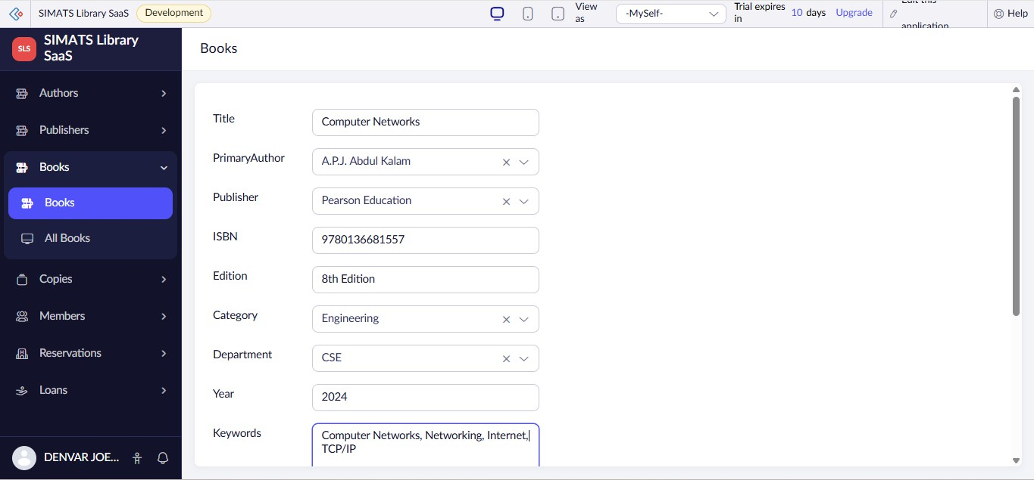
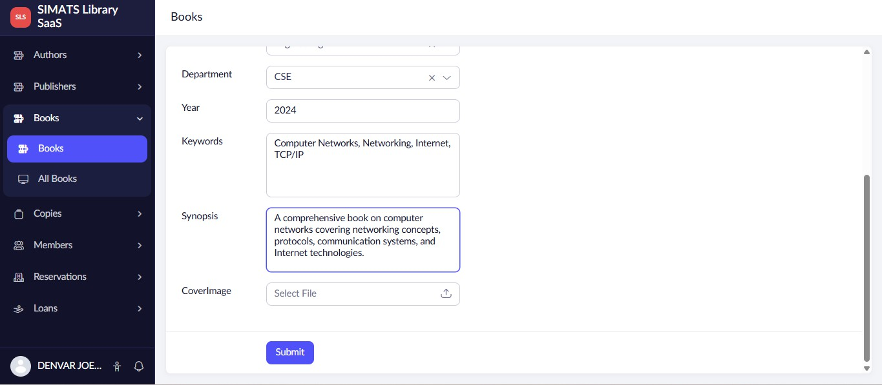
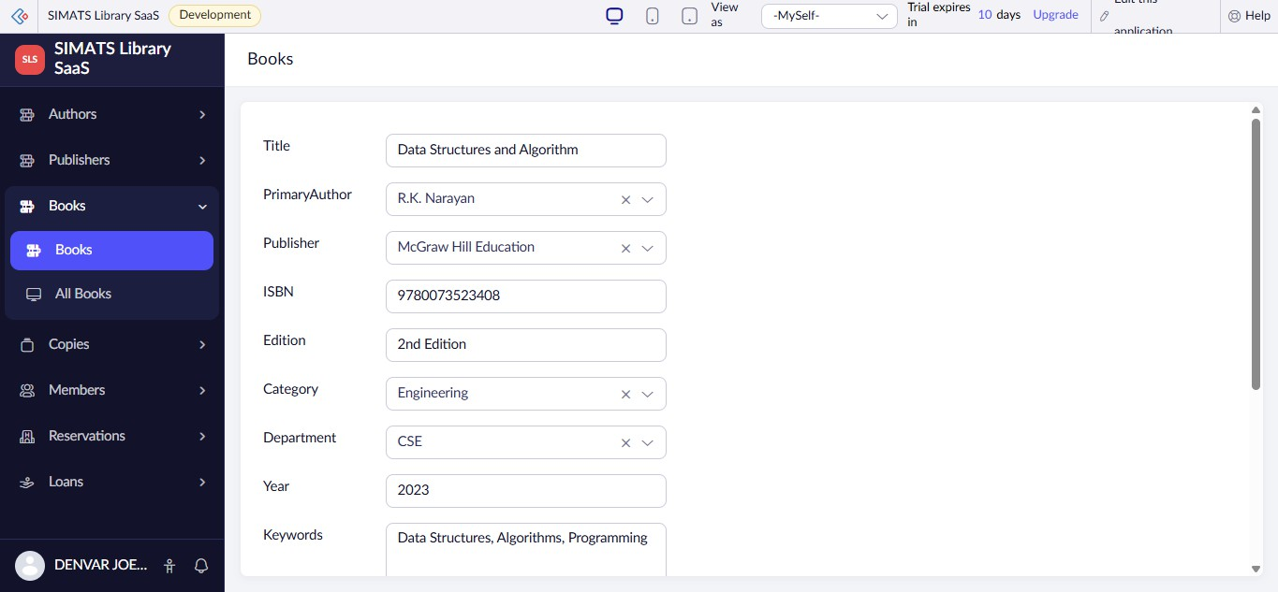

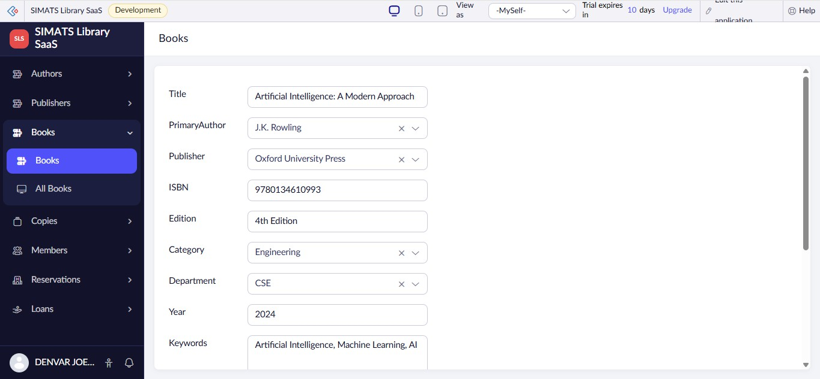
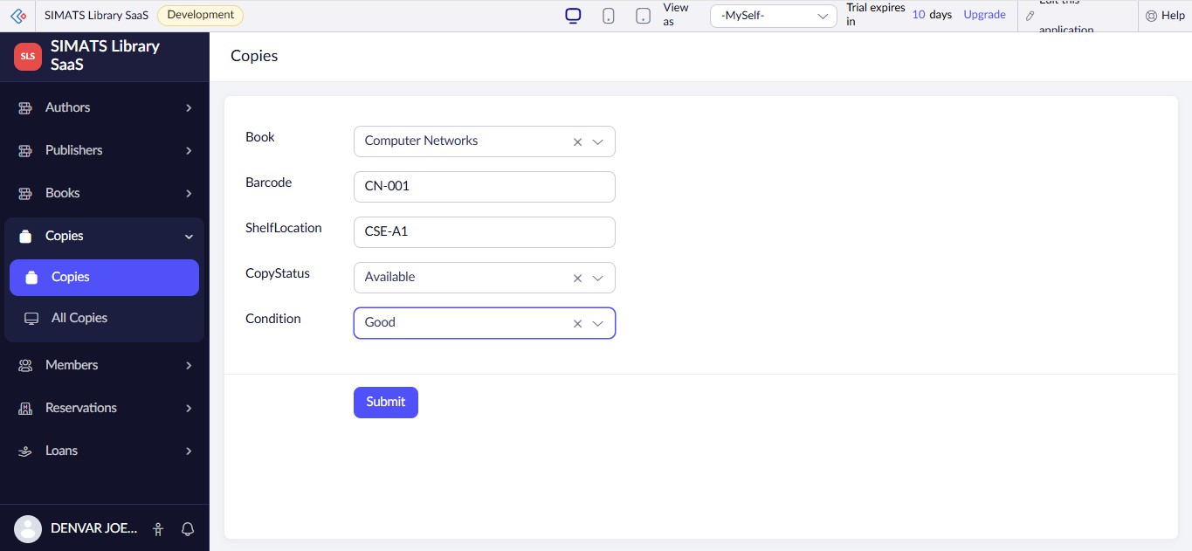
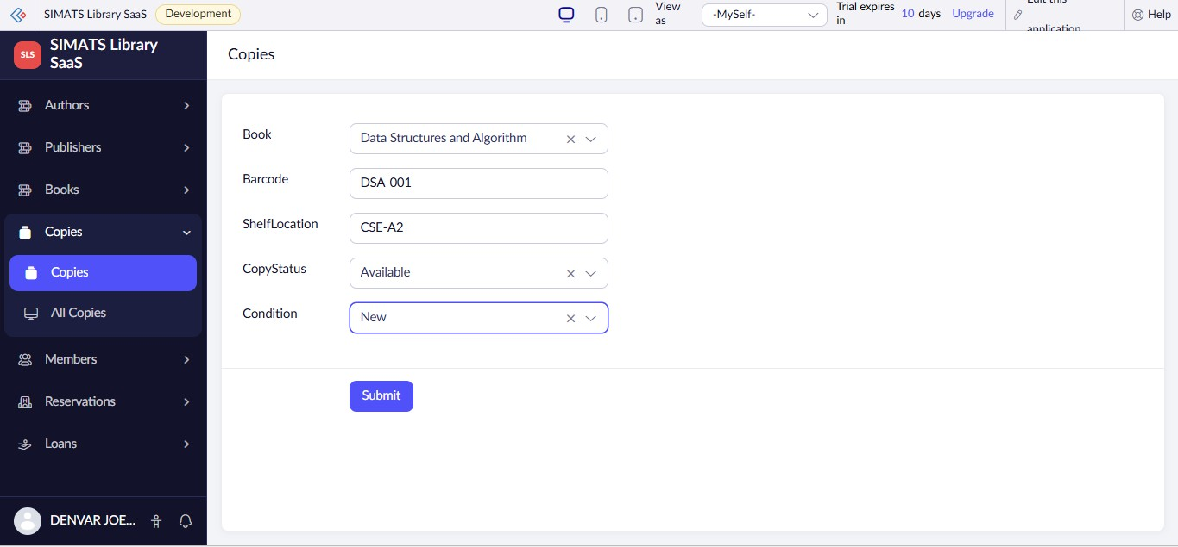

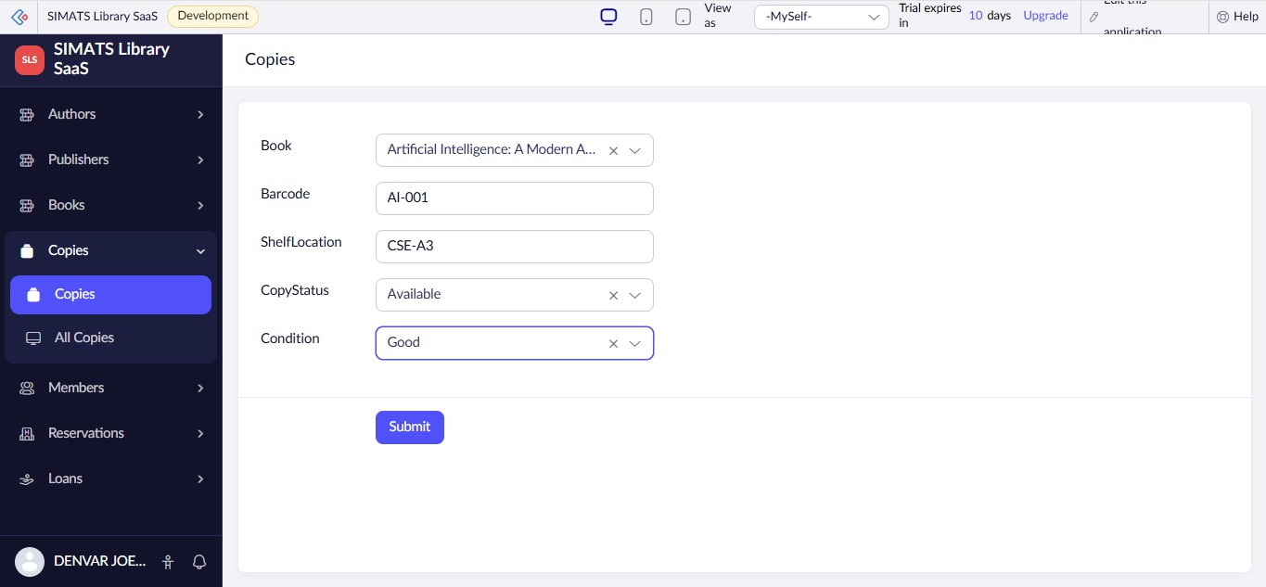
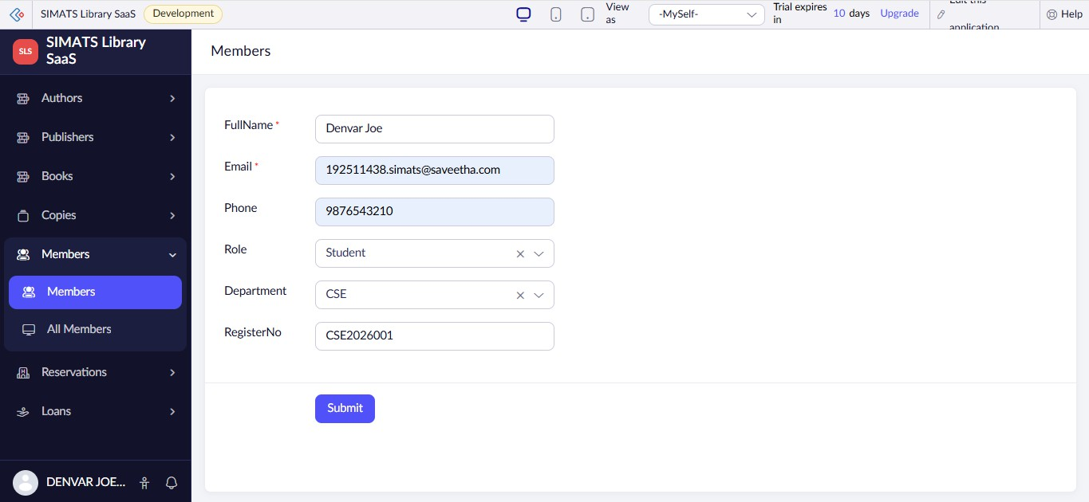
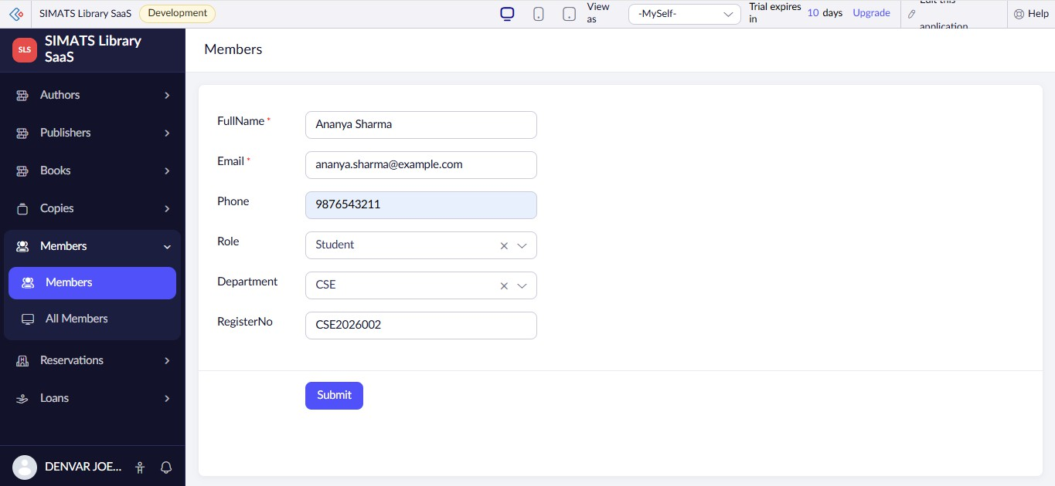

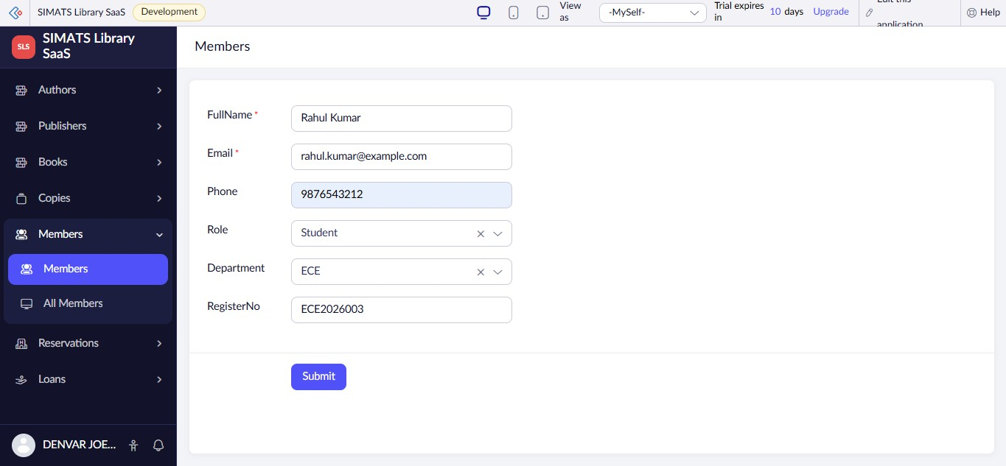
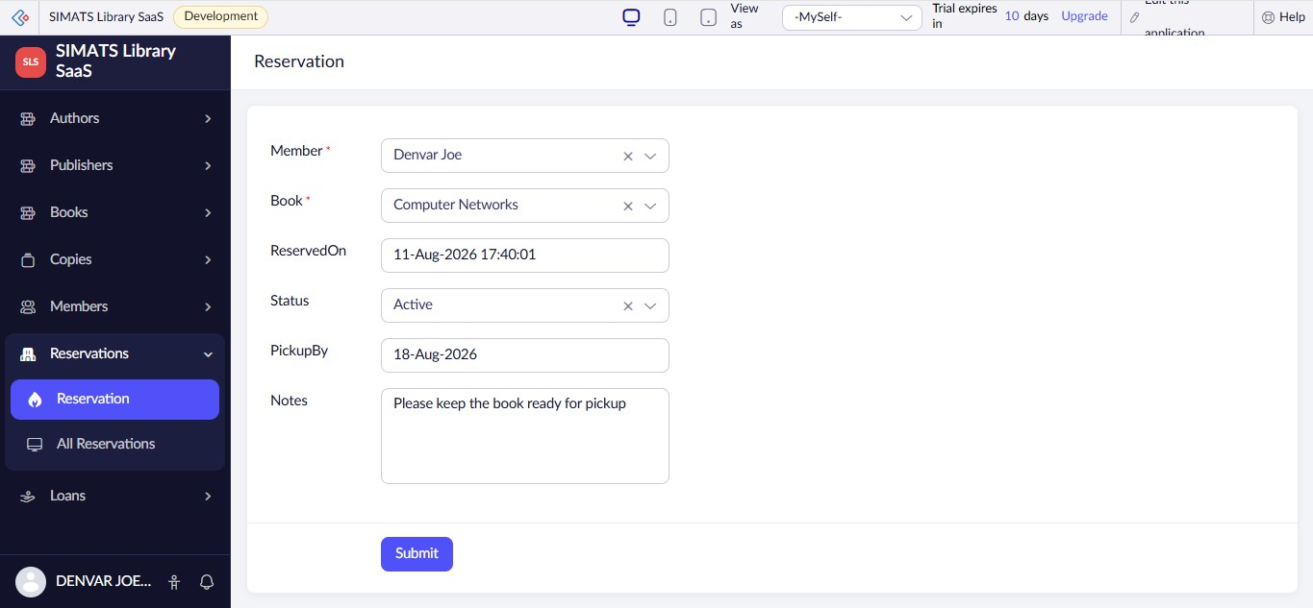
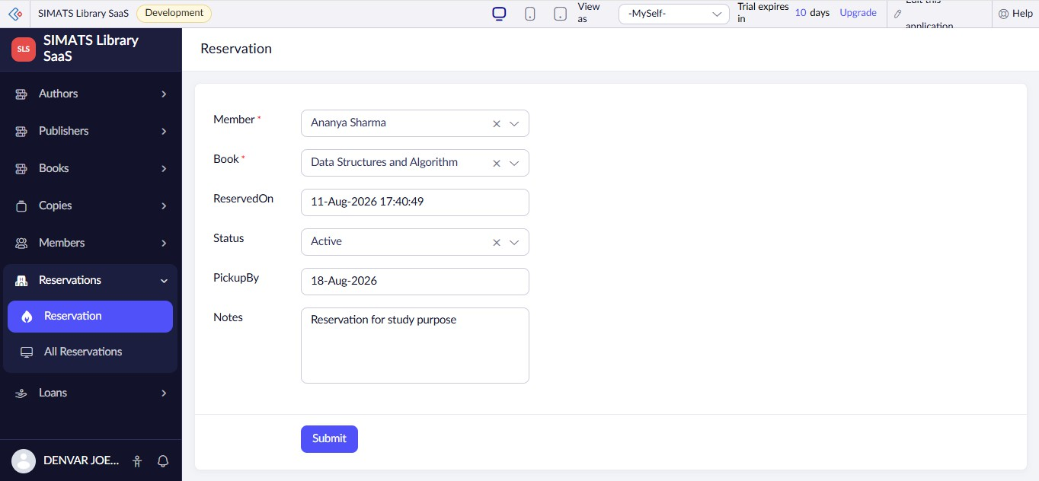

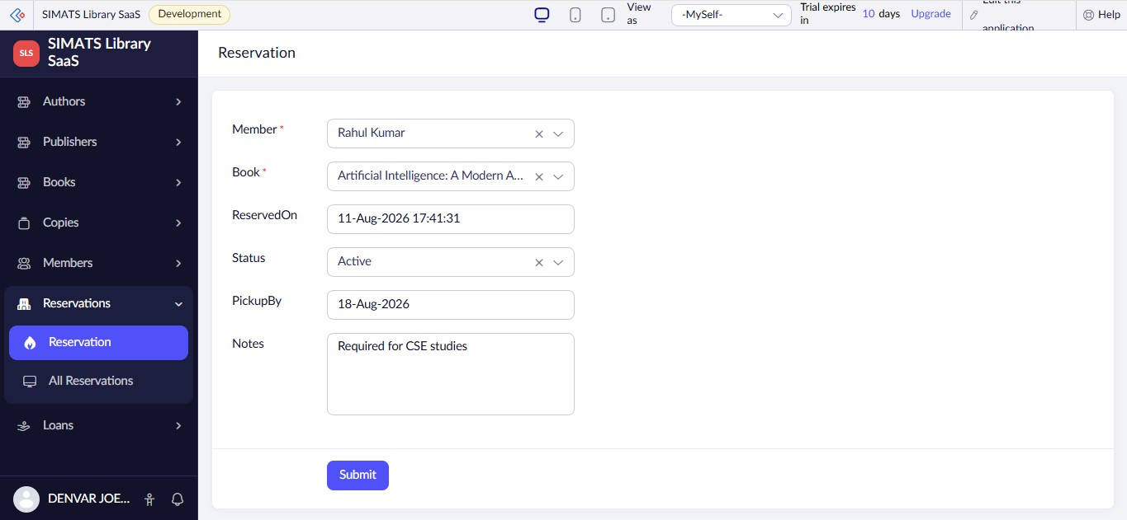
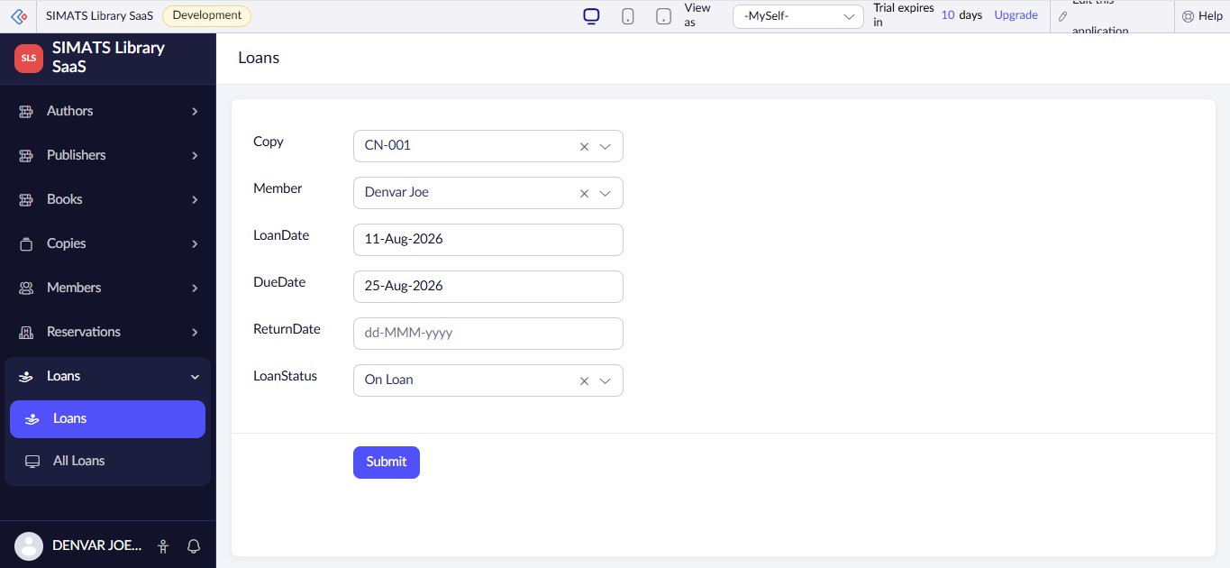
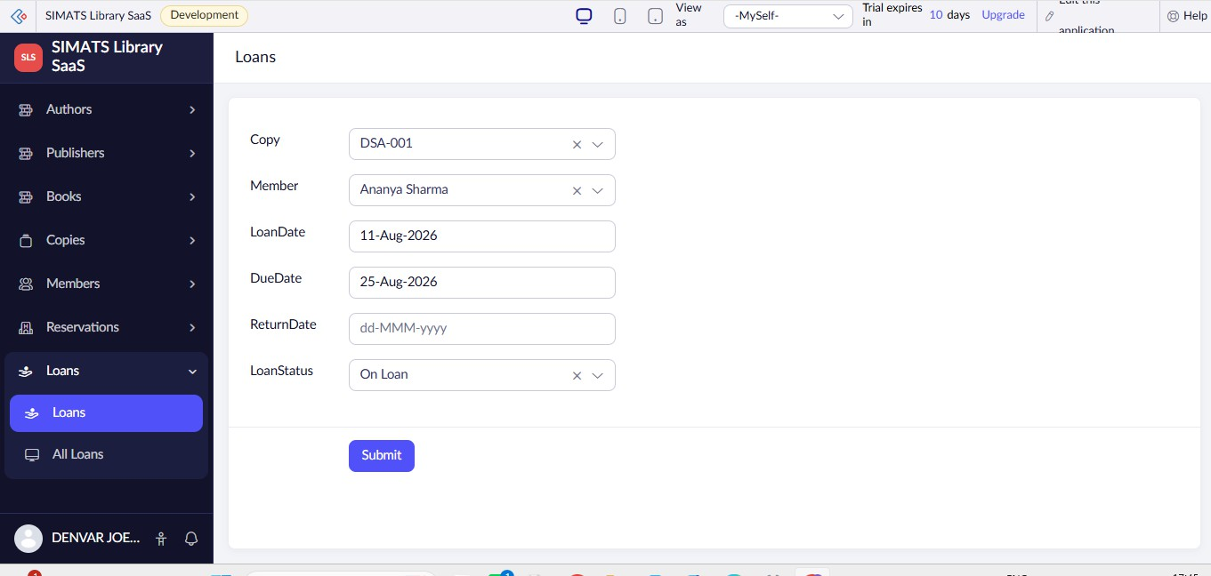

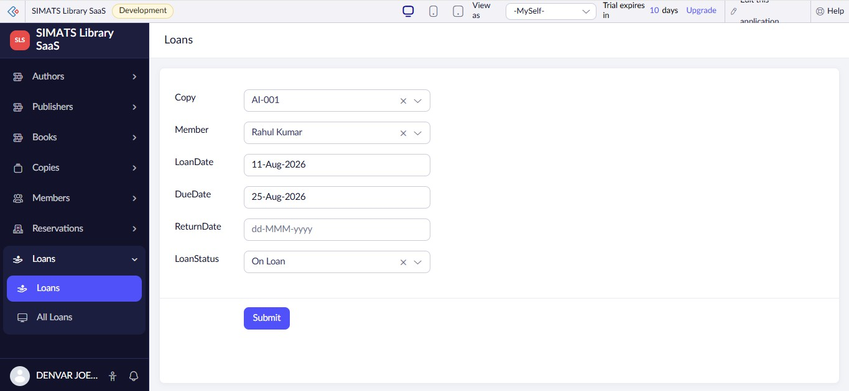

All Authors
AuthorName
Country

AuthorID | AuthorName Country |  | Notes
3 | J.K. Rowling | United Kingdom | British author and novelist
2 | R.K. Narayan | India | Indian novelist and writer
1 | A.P.J. Abdul Kalam | India | Indian scientist and author

All Publishers
PublisherName

publisherID | PublisherName | City
3 | Oxford University Press | New Delhi
2 | McGraw Hill Education | New Delhi
1 | Pearson Education | Chennai

All Books
Title
PrimaryAuthor
Publisher

BookID | Title PrimaryAuthor Publisher |  |  | ISBN | Edition | Category
3 | Artificial Intelligence: A Modern Approach | J.K. Rowling | Oxford University Press | 9780134610993 | 4th Edition | Engineering
2 | Data Structures and Algorithm | R.K. Narayan | McGraw Hill Education | 9780073523408 | 2nd Edition | Engineering
1 | Computer Networks | A.P.J. Abdul Kalam | Pearson Education | 9780136681557 | 8th Edition | Engineering

All Copies
Book
Barcode
ShelfLocation
CopyStatus

CopyID | Book Barcode ShelfLocation CopyStatus |  |  |  | Condition
3 | Artificial Intelligence: A Modern Approach | AI-001 | CSE-A3 | Available | Good
2 | Data Structures and Algorithm | DSA-001 | CSE-A2 | Available | New
1 | Computer Networks | CN-001 | CSE-A1 | Available | Good

All Members
FullName
Email
Phone
RegisterNo

MemberID | FullName | Email | Phone | RegisterNo | Role | Department
3 | Rahul Kumar | rahul.kumar@example.com | 9876543212 | ECE2026003 | Student | ECE
2 | Ananya Sharma | ananya.sharma@example.com | 9876543211 | CSE2026002 | Student | CSE
1 | Denvar Joe | 192511438.simats@saveetha.com | 9876543210 | CSE2026001 | Student | CSE

All Reservations
Member
Book
ReservedOn

ReservationID | Member Book ReservedOn |  |  | Status | PickupBy | Notes
6 | Rahul Kumar | Artificial Intelligence: A Modern Approach | 11-Aug-2026 17:41:31 | Active | 18-Aug-2026 | Required for CSE studies
5 | Ananya Sharma | Data Structures and Algorithm | 11-Aug-2026 17:40:49 | Active | 18-Aug-2026 | Reservation for study purpose
4 | Denvar Joe | Computer Networks | 11-Aug-2026 17:40:01 | Active | 18-Aug-2026 | Please keep the book ready for pickup

All Loans
Copy
Member
LoanDate
DueDate
ReturnDate

LoanID | Copy | Member | LoanDate | DueDate | ReturnDate | LoanStatus
3 | AI-001 | Rahul Kumar | 11-Aug-2026 | 25-Aug-2026 |  | On Loan
2 | DSA-001 | Ananya Sharma | 11-Aug-2026 | 25-Aug-2026 |  | On Loan
1 | CN-001 | Denvar Joe | 11-Aug-2026 | 25-Aug-2026 |  | On Loan

